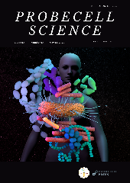 | PROBECELL SCIENCE  Journal homepage: https://probsci.com

Declaration of Conflict Interests

☐ The authors declare that they have no known competing financial interests or personal relationships that could have appeared to influence the work reported in this paper.

☐The authors declare the following financial interests/personal relationships which may be considered as potential competing interests:

